Burrow-Giles Lithographic Co. v. Sarony

111 U.S. 53 (1884)
Miller, J.:…The suit was commenced by an action at law in which Sarony was plaintiff and the lithographic company was defendant, the plaintiff charging the defendant with violating his copyright in regard to a photograph, the title of which is “Oscar Wilde No. 18.”…[The defendant assigns as error the finding of] the court below…that Congress had and has the constitutional right to protect photographs and negatives thereof by copyright.…
The constitutional question is not free from difficulty.…The argument here is, that a photograph is not a writing nor the production of an author. Under the acts of Congress designed to give effect to this section, the persons who are to be benefited are divided into two classes, authors and inventors. The monopoly which is granted to the former is called a copyright, that given to the latter, letters patent.…It is insisted in argument, that a photograph being a reproduction on paper of the exact features of some natural object or of some person, is not a writing of which the producer is the author.
Section 4952 of the Revised Statutes places photographs in the same class as things which may be copyrighted with “books, maps, charts, dramatic or musical compositions, engravings, cuts, prints, paintings, drawings, statues, statuary, and models or designs intended to be perfected as works of the fine arts.” “According to the practice of legislation in England and America,” says Judge Bouvier, 2 Law Dictionary, 363, “the copyright is confined to the exclusive right secured to the author or proprietor of a writing or drawing which may be multiplied by the arts of printing in any of its branches.”
The first Congress of the United States, sitting immediately after the formation of the Constitution, enacted that the “author or authors of any map, chart, book, or books, being a citizen or resident of the United States, shall have the sole right and liberty of printing, reprinting, publishing, and vending the same for the period of fourteen years from the recording of the title thereof in the clerk’s office, as afterwards directed.” 1 Stat. 124, 1. This statute not only makes maps and charts subjects of copyright, but mentions them before books in the order of designation. The second section of an act to amend this act, approved April 29, 1802, 2 Stat. 171, enacts that from the first day of January thereafter, he who shall invent and design, engrave, etch, or work, or from his own works shall cause to be designed and engraved, etched or worked, any historical or other print or prints shall have the same exclusive right for the term of fourteen years from recording the title thereof as prescribed by law.…
The construction placed upon the Constitution by the first act of 1790, and the act of 1802, by the men who were contemporary with its formation, many of whom were members of the convention which framed it, is of itself entitled to very great weight, and when it is remembered that the rights thus established have not been disputed during a period of nearly a century, it is almost conclusive.
Unless, therefore, photographs can be distinguished in the classification on this point from the maps, charts, designs, engravings, etchings, cuts, and other prints, it is difficult to see why Congress cannot make them the subject of copyright as well as the others. These statutes certainly answer the objection that books only, or writing in the limited sense of a book and its author, are within the constitutional provision. Both these words are susceptible of a more enlarged definition than this. An author in that sense is “he to whom anything owes its origin; originator; maker; one who completes a work of science or literature.” Worcester. So, also, no one would now claim that the word writing in this clause of the Constitution, though the only word used as to subjects in regard to which authors are to be secured, is limited to the actual script of the author, and excludes books and all other printed matter. By writings in that clause is meant the literary productions of those authors, and Congress very properly has declared these to include all forms of writing, printing, engraving, etching, &c., by which the ideas in the mind of the author are given visible expression. The only reason why photographs were not included in the extended list in the act of 1802 is probably that they did not exist, as photography as an art was then unknown, and the scientific principle on which it rests, and the chemicals and machinery by which it is operated, have all been discovered long since that statute was enacted.…
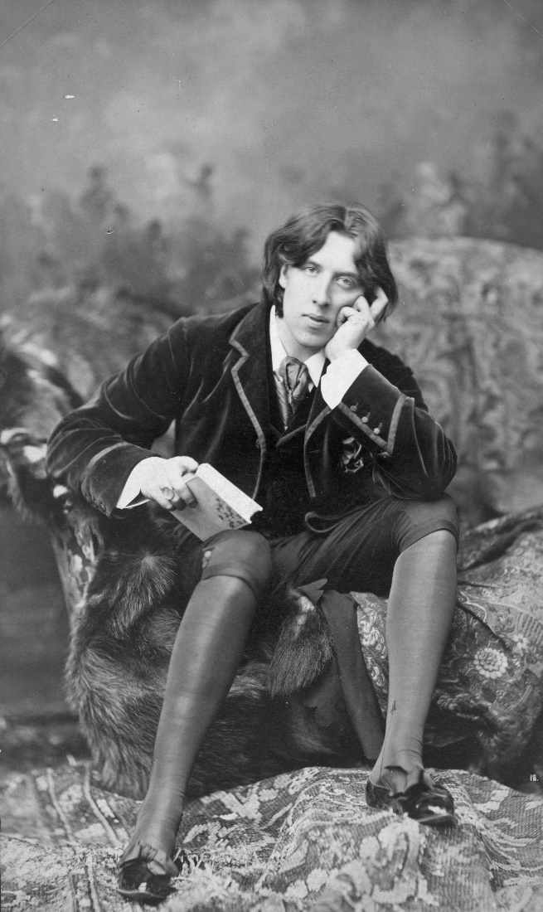
Oscar Wilde No. 18
We entertain no doubt that the Constitution is broad enough to cover an act authorizing copyright of photographs, so far as they are representatives of original intellectual conceptions of the author.
But it is said that an engraving, a painting, a print, does embody the intellectual conception of its author, in which there is novelty, invention, originality, and therefore comes within the purpose of the Constitution in securing its exclusive use or sale to its author, while the photograph is the mere mechanical reproduction of the physical features or outlines of some object, animate or inanimate, and involves no originality of thought or any novelty in the intellectual operation connected with its visible reproduction in shape of a picture. That while the effect of light on the prepared plate may have been a discovery in the production of these pictures, and patents could properly be obtained for the combination of the chemicals, for their application to the paper or other surface, for all the machinery by which the light reflected from the object was thrown on the prepared plate, and for all the improvements in this machinery, and in the materials, the remainder of the process is merely mechanical, with no place for novelty, invention or originality. It is simply the manual operation, by the use of these instruments and preparations, of transferring to the plate the visible representation of some existing object, the accuracy of this representation being its highest merit. This may be true in regard to the ordinary production of a photograph, and, further, that in such case a copyright is no protection. On the question as thus stated we decide nothing.…
The third finding of facts says, in regard to the photograph in question, that it is a “useful, new, harmonious, characteristic, and graceful picture, and that plaintiff made the same…entirely from his own original mental conception, to which he gave visible form by posing the said Oscar Wilde in front of the camera, selecting and arranging the costume, draperies, and other various accessories in said photograph, arranging the subject so as to present graceful outlines, arranging and disposing the light and shade, suggesting and evoking the desired expression, and from such disposition, arrangement, or representation, made entirely by plaintiff, he produced the picture in suit.” These findings, we think, show this photograph to be an original work of art, the product of plaintiff ‘s intellectual invention, of which plaintiff is the author, and of a class of inventions for which the Constitution intended that Congress should secure to him the exclusive right to use, publish and sell, as it has done by section 4952 of the Revised Statutes.…

